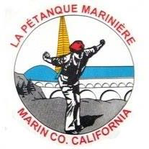
Petanque Mariniere, Board Meeting Minutes
June 10, 2024
At the courts

Board Members Present: Christine Cragg, , Sara Danielson, Shama Kota-Gutheti, Noel Marcovecchio, Mike O’Leary, Mark Toepfer, , Bart Zachofsky

Absent: Joe Danielson Louis Toulon

Guest: None

Call to Order: 10:12 AM

Motion to Approve the Minutes: MSC

Treasurers Report: Current balance: $6326

Motion to approve Treasurers’ report: MSC

Presidents Report The president’s report confused the secretary to the degree that he could not transcribe it.

Old Business: The May tournament which usually falls on Mother’s day will continue to be on Saturday and probably a melee.

New Business: LPM will participate in the Interclub tournament on 7/7
Gravel will be added to the courts.

For the Good of the Order:

Next Board Meeting: July 6, 2024, 10 AM On Zoom
Meeting adjourned at 11:12 AM
Minutes respectfully submitted by Noel Marcovecchio

