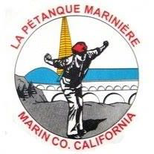
Petanque Mariniere, Board Meeting Minutes
June 10, 2024
Zoom

Board Members Present: Christine Cragg, , Shama Kota-Gutheti, Noel Marcovecchio, Mike O’Leary, Louis Toulon, Bart Zachofsky

Absent: Joe Danielson, Sara Danielson, Mark Toepfer,

Guest: None

Call to Order: 10:11 AM

Motion to Approve the Minutes: MSC

Treasurers Report: Current balance: See president’s memo

Motion to approve Treasurers’ report: MSC

Presidents Report: The president spared the secretary of interpreting what she said into logical form and did not give a report.

Old Business: Concerning the interclub tournament, The entry fee will be paid by LPM in perpetuity or until the board changes its mind.

New Business: Flyers for the next tournament will be sent out and a general discussion of future tournaments were discussed

For the Good of the Order: No good came at this time

Next Board Meeting: August 2, 2024, 10 AM at Pierre Joske Petanque PArk
Meeting adjourned at 10:27 AM
Minutes respectfully submitted by Noel Marcovecchio

