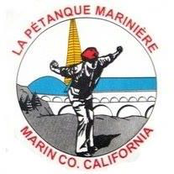
Petanque Mariniere, Board Meeting Minutes
December 7, 2024
Zoom

Board Members Present: Christine Cragg, Sara Danielson, Shama Kota-Gutheti, Noel Marcovecchio, Mike O’Leary, Mark Toepfer, Bart Zachofsky

Absent: Joe Danielson, Louis Toulon

Guest: None

Call to Order: 10:001

Motion to Approve the Minutes: MSC

Treasurers Report: See Report

Motion to approve Treasurers’ report: MSC

Presidents Report : Despite overwhelming encouragement there was none.

Old Business: The FPUSA has approved our request for Select Doubles on October 11,2025.
The Board put the 2025 calendar together.

New Business: Discussions concerning the running of the January 2025 tournament.

For the Good of the Order: None

Next Board Meeting: February 1,2028 Location to be announced.
Meeting adjourned at 11:04
Minutes respectfully submitted by Noel Marcovecchio

