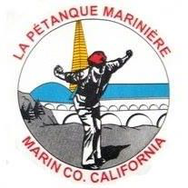
Petanque Mariniere, Board Meeting Minutes
November 2, 2024
Zoom

Board Members Present: Christine Cragg, Joe Danielson, Sara Danielson, Shama Kota-Gutheti, Noel Marcovecchio, Mike O’Leary, Mark Toepfer, Louis Toulon, Bart Zachofsky

Absent: None

Guest: None

Call to Order: !0:00 AM

Motion to Approve the Minutes: MSC

Treasurers Report: See report

Motion to approve Treasurers’ report: MSC

Presidents Report: Mercifully short

Old Business: 2025 Calendar. First tournament, January 9, 2025. Weather permitting.

New Business: Discussion to return tournaments to Sunday. Because of antiques market and holidays, tournaments will remain on Saturday.

For the Good of the Order:

Next Board Meeting: December 7, 2024 on Zoom
Meeting adjourned at 10:34 AM
Minutes respectfully submitted by Noel Marcovecchio

