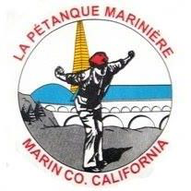
Petanque Mariniere, Board Meeting Minutes
September 27, 2024 (October Meeting)
Zoom, 10:00 AM

Board Members Present: Christine Cragg, Sara Danielson, Shama Kota-Gutheti, Noel Marcovecchio, Mike O’Leary, Mark Toepfer, Louis Toulon, Bart Zachofsky

Absent: Joe Danielson

Guest: None

Call to Order: 10:10 AM

Motion to Approve the Minutes: MSC

Treasurers Report: Waived

Motion to approve Treasurers’ report:

Presidents Report: The president reported on new members.

Old Business: 1. Discussion of annual meeting. 2. Planning for October tournament

New Business: 1. Skills clinic to land on lesson days. 2. I have a note about Sandra Shirkey and indoor petanque but have no recollection of the content.

For the Good of the Order: Condition of Noah discussion and agreement for LPM to donate to Go Fund Me.

Next Board Meeting: 11/2/2024, 10 AM Location at the courts
Meeting adjourned at 11:15
Minutes respectfully submitted by Noel Marcovecchio

