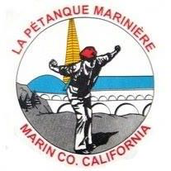
Petanque Mariniere, Board Meeting Minutes
Sept 6, 2024
Pierre Joske Petanque Park
10:00AM

Board Members Present: Christine Cragg, Joe Danielson, Sara Danielson, Shama Kota-Gutheti, Noel Marcovecchio, Mike O’Leary, Mark Toepfer, Bart Zachofsky

Absent: Louis Toulon

Guest: None

Call to Order: 1-:24

Motion to Approve the Minutes: MSC

Treasurers Report: $6683

Motion to approve Treasurers’ report: MSC

Presidents Report: Imaginary

Old Business: 1. Commemorative Cup practical issues. 2. Clinic discussion future planning.

New Business: 1. FPUSA dues increase. 2 2025 Calendar planning discussion commenced.
3. Discussion about possible tournament types for 2025. 4. New league play suggested. 5 October business meeting planning.

For the Good of the Order: None recalled

Next Board Meeting: 9/27 On Zoom
Meeting adjourned at 11:35
Minutes respectfully submitted by Noel Marcovecchio

