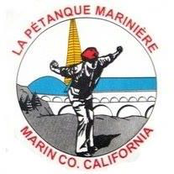
Petanque Mariniere, Board Meeting Minutes
August 3,2024
Pierre Joske Park

Board Members Present: Christine Cragg, Joe Danielson, Sara Danielson, Shama Kota-Gutheti, Noel Marcovecchio, Mike O’Leary, Mark Toepfer, Louis Toulon, Bart Zachofsky

Absent: Any members’ absence went unnoticed by the secretary.

Guest: None

Call to Order: 10:07AM

Motion to Approve the Minutes: MSC as amended

Treasurers Report: $6685 + $300 petty cash

Motion to approve Treasurers’ report: MSC

Presidents Report: The president announced the use of a new procedure to make the handling of money on tournament days simpler.

Old Business: Discussion concerning August 10,2024. Payout to be 100%. Other administrated details discussed.

New Business: Discussion concerning the administrative details of the Commemorative Cup details discussed.

For the Good of the Order: Mark proposed a morning of training exercises and undertook the project. Joe proposed a new flyer be posted where appropriate.

Next Board Meeting: Sept 7, 2024 now amended to September 6 ,2024 at 10AM.
Location: Pierre Joske Park
Meeting adjourned at 11AM
Minutes respectfully submitted by Noel Marcovecchio

